Code9: Return
#include<stdio.h>
#include<stdlib.h>

double cube(double num){
double result = num * num * num;
return result;
}

int main() {
printf("Answer: %f", cube(3.0));
return 0;
}

Output:
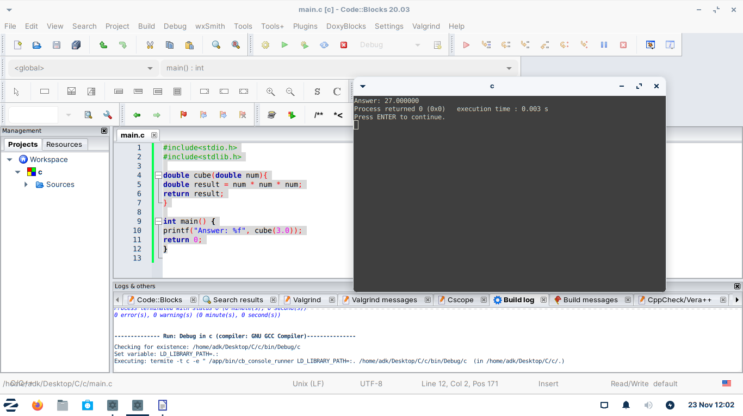

code10:If loop
#include<stdio.h>
#include<stdlib.h>
int max(int num1, int num2){
int result;
if(num1 > num2){
result = num1;
}
else {
result = num2;
}
}
int main() {

printf("%d", max(4, 10));

return 0;
}
Output:
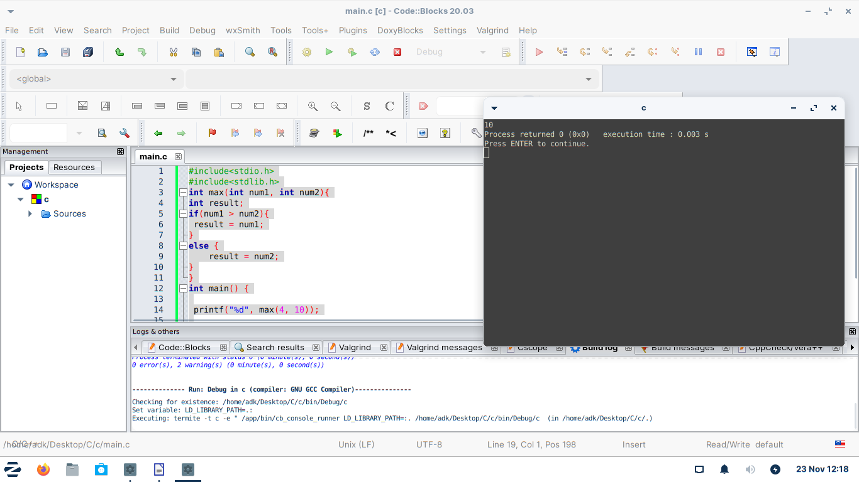

Code11:Building a better calculator.

